Game Design Document

Fill up the following document

1. Write the title of your project.

Balloon Rider

1. What is the goal of the game?

To reach the destination without getting attacked

1. Write a brief story of your game.

Group of friends were going on a balloon ride in between they facing some difficult situation. Players should help them to dodge the obstacles and also help them to reach their favourite destination.

1. Which are the playing characters of this game?

* Playing characters are the ones who respond to the user based on the input from the user.
* Cars, monkeys, dinos, wizards, etc., are the playing characters in the game.

|  |  |  |
| --- | --- | --- |
| Number | Character Name | What can this character do? |
| 1 | BT21 | They can ride the balloon |
| 2 |  |  |
| 3 |  |  |
| 4 |  |  |
| 5 |  |  |
| 6 |  |  |
| 7 |  |  |
| 8 |  |  |

1. Which are the Non-Playing Characters of this game?

* Non-Playing characters are the ones that don't have an action or behavior when the user interacts with the game.
* Hurdles, stones, bananas, coins, etc., are non-playing characters in the game.

|  |  |  |
| --- | --- | --- |
| Number | Character Name | What can this character do? |
| 1 | Birds | They can attack |
| 2 |  |  |
| 3 |  |  |
| 4 |  |  |
| 5 |  |  |
| 6 |  |  |
| 7 |  |  |
| 8 |  |  |

Draw your imagination of this game. What does this game look like?

* Draw the game either on your computer or on paper.
* Add images of the game scenes to show each of the playing and non-playing characters at least once.

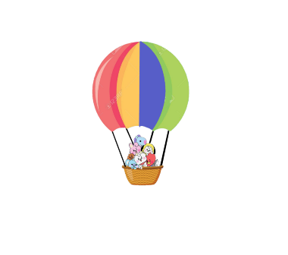

How do you plan to make your game engaging?

This game can improve your dodging skills in video games.

Unpredictable attacks make it more thrilling.